Broughton Community Schools

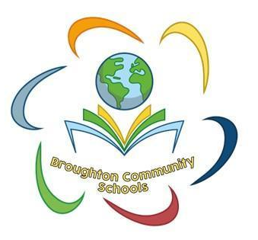

Regulation and Relationships Policy

September 2026

Section 1 - Introduction
1a. Our Core beliefs and Values

At Broughton Community Schools (BCS) we are committed to being a ‘Trauma Informed and Attachment Aware’ community. We are aware that to ensure everyone in the school community feels safe, the educational environment needs to be high in both nurture and structure. All children and young people need predictable routines, high expectations and consistent yet caring responses to behaviour. These fundamentals must be in place and modelled appropriately.

We recognise that for children to THRIVE and progress in their learning, we must first address their need for a sense of safety and belonging (Maslow’s Hierarchy of Needs – see Appendix 1). We wish to work towards these important goals in all aspects of school life, and to provide an ethos, environment and curriculum that supports the whole school community. It is acknowledged that members of the school community may have vastly different parenting experiences and views on behaviour. However, the aim of our Regulation and Relationships Policy is to bring us all together to adhere to some key principles and practices that reflect our school ethos. Relational responses are the foundations of this approach.

Our BCS values are at the heart of the positive relationships we build, between adults, children and our wider Community. We expect all members of our school community to be: Ready, Respectful and Safe:

Ready:
We will be present and available for children, colleagues and the wider community and will act decisively and supportively.

Respectful:
We are respectful towards our children and treat them well. We will model throughout all interactions, considerate, professional and respectful behaviours with all members of the school community.

Safe:
We will ensure a safe school community by developing and maintaining positive relationships and engaging with the Trauma Informed approach to all interactions within the school community.

1b. The Impact of Disruption on children
Babies are born with a need for connection and safety. They are not only dependent on
their primary caregivers to meet their basic needs of food, water, warmth and rest, (Maslow’s 5 Levels of Human Need – See Appendix 1) but in order to thrive, babies need love, belonging, safety and security; without this, their need for connection and safety are not met. The impact of a disrupted early childhood creates adverse childhood experiences (ACEs). Without the power of kind, understanding, positive relationships; disruption can shape the future lives of our children.

1c: The Power of Relationship
The power of the positive relationships we build and nurture with our children is at the heart of our policy. ‘Every relationship has the power to confirm or challenge all that’s gone on before’ (Bombér 2007). We acknowledge all of our children will have received different early childhood experiences depending on the love, care and nurture they will have received from their families. We believe it is the responsibility of schools to intentionally create positive relationships where all children thrive, helping all children especially those who enter school having had a difficult early childhood.

1d: Celebrating Difference
At BCS, we fully recognise that all of our children are different and unique. We communicate the message of celebrating differences in a number of ways:

- Value and celebrate differences and diversity.
- Using opportunities within the curriculum to teach our children that it is okay to be different.
- Know the importance of having a flexible approach to supporting our children; one size does not fit all!
- We not only adapt the curriculum, but also the way we treat our children.
- Acknowledge all of our children have a very different starting point.
- Speak to each other respectfully and as equals; show appreciation for each other and value their strengths.
- Through being respectful towards all of the children in our care; being mindful of verbal and non-verbal communications, knowing that the children pick up on how we relate to them and their peers and will model this in our interactions with each other.
- Through being respectful towards our families; they know the importance of partnership. We are aware that we are going to have different perspectives, beliefs and values. When working with our families we must remain professional and will not allow our own beliefs to interfere with creating a positive, professional working relationship.
- Directly and indirectly communicating differences. We celebrate differences directly in assemblies, during PSHE lessons, Wellbeing lessons and in other areas of the curriculum and school life. We indirectly communicate differences when we manage interactions between children, we celebrate what children can do

Section 2 – Expectations and Impact
2a: Expectations for staff
- We recognise that each adult working in our school comes with different life experiences and has a range of different skills. We all have different starting points as staff, with varying capacities in relation to our connection needs as human beings. However, we have a expectations which we expect all members of our team to subscribe to.
- We support our staff to be committed to their own learning and training, to be open to trying different ways to support our children. We acknowledge we will all have different experiences and training; our aim is to provide training for all. We will remember some of the children in our care, who have experienced developmental trauma, have a very fragile sense of self.
- To be self-reflective and to recognise we are always learning. We listen to each other and are open to trying out new ways to support our children. We want our staff to remain calm and regulated. If this becomes challenging, we encourage our staff to support each other and swap adults as needed, in order to be the most appropriate adult to support a particular child.
- We know how important it is to remain regulated throughout the school day, to take regular quality breaks and look after ourselves. We expect staff to be kind to themselves and each other.
- We always remember connection is at the heart of our relationships with our children. It will be during the most challenging times that our children need connection the most. Our children need to build trust and have the security of knowing that they are unconditionally accepted by us. Our children need to build safe relationships with all staff but have the deepest relationship with their key adults.

2b: Expectations for pupils
      - We know that all of our children have had different childhood experiences and will come to us with different starting points.
      - We know each of our children will present with different sensitivities, vulnerabilities and resiliencies; we will see it as our responsibility to learn about our pupils and differentiate our care. All functioning depends upon the state the children are in. Children can move very quickly from calm to fear, when stressed or experiencing threat. Feeling in a state of fear will look different for each of our children depending on their early experiences.
      - In order to support our pupils to feel safe at school and to settle to learn, we need to differentiate emotional and social tasks and expectations. This means our children may need support when working in a group; during unstructured breaks or lunch times; they may struggle to be in assembly etc. We get to know our children and to be flexible in the support we offer.
      - School can be very challenging for some of our pupils, by connecting cognitively and emotionally with our pupils we will learn what is a ‘Big Ask’ for individual children and consider what we can put in place to reduce their anxiety levels, e.g. not participating in whole school assemblies, support with transition between lessons/activities, etc.

Section 3- A Graduated Approach
‘Behaviour and discipline in schools: Advice for head teachers and school staff’ draws on the behaviourist principles of ‘reward and sanction’ which although may help to modify the behaviour of many children and young people, do not work for all children. This is particularly true for those who have historic or current ‘Adverse Childhood Experiences’ (ACEs). Whilst our behavioural approach outlined in this policy will be effective for the majority of children at BCS, some children will require extra support. We view all behaviour as a communication of need, therefore where children may be experiencing frequent difficulties we will view this as an indication that the level of support may need to be increased. Decisions about the level of support required will usually be made in consultation with the child, their parents / carers and external professionals as appropriate.
The steps below outline a graduated approach to endure everyone THRIVES within our school:

3a. Step 1 – Establishing and maintaining relationships
At BCS, every member of staff has a collective responsibility to build positive relationships. It is everyone’s responsibility to care for, and nurture our children. Our children thrive when they are seen, heard and recognised. Helping all pupils to realise the value of relationships, and, how to keep them healthy and thriving, is a lifelong skill and one which will positively impact their mental health and well-being into adulthood.

Relationships are the most therapeutic and healing aspect of a ‘Trauma Informed and Attachment Aware’ approach. They will need to firstly be established and maintained in the following ways:

- Know the story - we see our children as unique individuals with their own story. We invest in relationships with their families to understand their story.
- We expect staff to be warm and open, to smile at our children, to use their names and greet them in the morning.
- Meet and greet our children at the school gates and classroom door so they feel seen.
- Staff understand that we as adults need to identify and manage our own triggers.
- Recognise that as adults our own values and beliefs will interact with cultural, ethical, and generational differences.
- It is important adults facilitate ‘quality moments’ during the day by pressing pause and being physically and emotionally present, attentive, attuned and responsive.
- Help children feel ‘held in mind’ (I thought about you the other day when …. I remember you like ….)
- Follow through with things we say we will do, especially the positive things.
- Role model acknowledging our own mistakes and negative emotions, showing how we learn from them in order to move forward.
- Maintain high levels of self-awareness as adults so that we can make deliberate use of positive body language and other non-verbal communication.

3b. Step 2 - Rewards and positive reinforcement
The intrinsic reward offered by warm relationships, verbal praise and a stimulating curriculum are the most effective forms of reward for all children. However, at BCS we recognise that for many children a more tangible reward system, which recognises all forms of social and academic achievement and which regularly communicates this 'good news', is necessary.

As a whole school:
- Rewards and reinforcement are linked to achievement and progress in both academic and social/emotional functioning. Weekly Values Certificates are given to pupils who demonstrate the school values.
- Rewards and reinforcement are given as quickly as possible after the positive behavioural/academic success. At the very minimum it is expected that Values Certificates, Superstar Stickers, House Points and verbal contact with parents are strategies used to support positive reinforcement of behaviour.
- Every child experiences some success and recognition – we recognise this is especially important for our vulnerable cohorts who may be struggling to conform and manage their emotions.
- There are multiple opportunities during the day/week for a fresh start.
As an individual staff member:
- The most powerful reward a staff member can bestow on a child is positive attention.
- Children need feedback regularly to help them improve academically. They also need regular feedback to help them develop socially and emotionally.
- Frequent ‘positive noticing’ is a powerful and effective form of positive reinforcement (Thank you for being so helpful today … I noticed how you asked for help today when you were unsure … I liked how politely you …).
- Praise and acknowledgment are most effective when it is experienced as genuine and specific (and for children who have experienced trauma, focus on an outcome or a concrete action rather than the individual).
- Praise and acknowledgement can be communicated through other means including displaying and celebrating achievements.
- There is acknowledgement that some children respond positively to public praise, whereas others may need more private recognition.

3c. Step 3 - Building resilience and developing self-regulation
At BCS we take a proactive whole-school approach to promoting prosocial behaviour. We recognise that an important part of this approach involves building resilience and improving our children’s ability to self-regulate. This is aligned with a ‘Trauma Informed and Attachment Aware’ approach and will benefit the whole school community while addressing the needs of pupils who have experienced trauma and attachment issues.

Building resilience and improving self-regulation involves direct and indirect learning. Direct learning can only occur when pupils are functioning at baseline (not at times of crisis).

Direct learning opportunities:
- Our school values such as kindness and resilience are promoted through day-to-day interactions and the curriculum including lessons such as P.S.H.E and Wellbeing. In these lessons, pupils are taught some simple self-regulation strategies so they can manage stress and conflict, building their resilience (grounding strategies, mindfulness etc).
- Explicitly teaching emotional literacy to all pupils as part of the school curriculum through interventions such as Calming Kittens and Zones of Regulation (recognising the physical representation of emotions, labelling emotions) as well as Apple’s Friends and Nurture Group.
- The Nurturing Programme is delivered internally to support parents and carers when managing resilience and regulation at home.
- Outside agencies also provide support for families, such as the Mental Health Support Team (MHST) and Play Therapy.

In-direct learning:
- Children and young people are supported by staff who understand the importance of seeing all behaviour as communication and who assume complexity and trauma may be present and therefore use their professional curiosity alongside positive language to respond rather than react.
- See the child - we recognise every child in our care is unique and will have come to us with different experiences. We will communicate acceptance of their lived experiences, their feelings, their way of interpreting themselves, others and the contexts they find themselves in. We will treat them in a kind, empathetic way, without any judgement. We will use opportunities within our wider curriculum, such as Forest School lessons and visiting the animals on site to find quality moments of connection with our children, where we will be intentionally physically and emotionally present.

3d. Step 4 - De-escalation of dysregulated or connection seeking behaviour
Providing high quality, adaptive teaching alongside practicing resilience, regulation and relationship building are all major factors in ensuring a positive learning environment for all; this will go a long way towards minimising dysregulated or connection-seeking behaviour. However, the school recognise there will be times when children do require support to regulate themselves and accept the boundaries which are clearly communicated to them. It is at this stage that a consistent approach using a ‘shared language’ is most important.
Connection before correction using PACE
PACE is an evidence-based approach to communication with children and young people who have experienced trauma. However, as it is based on neurological responses to human interaction, it is an effective approach for all pupils. It can be used very effectively alongside the Step On scripts (See Appendix 2a, 2b and 2c).
Playfulness:
- Playfulness means being warm, open and engaged, using chat and humour to make learning fun. It involves smiling and using big gestures.
- Using a playful tone of voice, warm gestures and humour can go a long way to diffuse low level behavioural dysregulation or when children and young people are ‘seeking connection’. (It’s lovely to see you today. What’s all this about … I am sure we can work on this together.)
- Offering limited choices can also be a very effective, light-hearted, way to address low level dysregulation (Ok so you are having a bit of trouble getting started. Let’s see how we can get this show on the road: you can write this by hand or use the laptop).
Acceptance:
- This involves communicating our understanding of a child’s experiences, feelings and beliefs. It doesn’t mean it matches our own interpretation or meaning, but we are accepting that our children have a different reality to the one we do or think they should do. This involves being open with our body language and using words such as ‘Help me to understand’, ‘I see’.
- Accept their intentions and redirect (Accept: When you make silly noises, you are letting me know that you are finding things difficult right now. Redirect: I’m here to help. You talk, I’ll listen and we’ll resolve this together / Remember, in the classroom we work quietly so everyone can concentrate. Yesterday you worked quietly in Maths. That’s what we need to see today. Just put up your hand if you want some help).
- Be consistent, kind but firm.
Curiosity:
- By being curious we help develop curiosity in our children. Our children grow and learn by being curious about themselves, others and the world around them. Curiosity leads to self-awareness: self-awareness leads to self-control.
- Listen to and observe the child's communication, it may not be verbal, then reflect back what you have observed (I can see that you are agitated / distracted / demotivated right now … I wonder if you are struggling with … I guess you might be worried about … )
- A response may not be forthcoming initially. Give take up time where possible and let them know you will ‘return to see how they are doing’ in a few minutes.
- When you return, keep the tone light but remind them of the expectations and use positive language as much as possible (Ok it’s been a few minutes. It’s good to see you have picked up your pen / lifted your head off the table / settled down in your seat and are more ready to make a start. Let me remind you of what you needed to do.)
Empathy:
- It is so important to show true empathy to our children, to show we are interested in them and care about their struggles. As we get to know our children better it will be easier to experience empathy for them.
- Acknowledge and validate feelings then redirect (Acknowledge: I hear / see that you are not happy about … Validate: I understand it’s hard when … Redirect: Remember, in our school we are respectful to each other so when you … then we can look at …).
- Be tolerant but not permissive – remember high nurture and high structure are key.

Safe Spaces
We know that some of our children benefit from safe spaces. We create safe spaces depending on each child’s individual needs; some safe spaces will be in reading corners of the classroom, others in rooms within the school, e.g. Library, Sensory rooms, The Bridge, The Ark. A safe space provides a child with somewhere to ‘down load’ or process everything that’s been happening. Classrooms are busy environments, some of our children can become overwhelmed and dysregulated. Depending on a child’s needs, they may be supported to go there when a member of staff feels it would be beneficial for them to do so. Our children can also ask their key adult / teacher if they need to use their safe space.

3e. Step 5 – Seeking additional support, where connection is not reciprocated
There will be times when a PACE. approach does not result in positive behavioural outcomes within the classroom environment. Sometimes children won’t initially reciprocate our connection with them particularly if they have been let down by adults in the past. They may deliberately ‘push us’ away and now present with ‘blocked trust’. At this point there may be a need to seek additional support for children.

Additional support:
- Removing the audience can be very helpful, this includes other adults (or removing the child from the audience if possible).
- A change of environment may be needed - e.g. movement break. Support may be sought from the supporting LSA in the classroom, Wellbeing Support Officer or a member of SLT to accompany the child to a reflection/regulation/ready to learn area. This is a space for pupils to:
- Regulate - time and space to calm down and soothe the brain stem using strategies such as quiet time, reading a story, time with the school animals, movement outside
- Relate - connect with the child – PACE may be effective now without an audience and with time to regulate. Show empathy and understanding. Communicate your care for them, invite them to join your games and activities and always remain consistent, open and warm.
- Reason - reflect and articulate. Some learning is needed to move forward and this can be achieved through PACE initially to make the ‘connection’ and then the ‘correction’ or thinking about alternative behaviours can follow on. Wonder aloud for example, I can see it’s really hard for you to do up your shoelaces, can I help you? It’s nice to let people who care about us help us. In this example, we are teaching the child it’s ok to be dependent on adults who care for us. Children learn to be dependent before they become independent.
- Repair - problem solve together on how this temporary rupture in the relationship can be repaired. A simple apology, restorative conversation, restorative action which may happen at an appropriate time once the child is calm and regulated. Once this step is complete there is a fresh start.
- Additional support is most likely to be effective for children (particularly those who have trauma and attachment difficulties) if the adult involved in giving the support is one of up to five adults they have identified as ‘trusted, safe adults’. Remember that the children who resist us them most need us the most.
3f. Step 6 - Supporting children and young people in a crisis
Sometimes, despite our best efforts, children can become very dysregulated and as a result they will experience a crisis. At this stage, their fight or flight response will be engaged and therefore their ‘thinking’ brain’ will be offline. When dealing with serious incidents we have to remember how thinking, feeling and behaviour are connected. When we understand the motivation for the behaviours, the reasons why a child has behaved in a certain way, we are in a better position to know what is the best fit for this particular child and situation. Serious incidences will be dealt with care and empathy.
The following are important steps when supporting children in crisis:
- Start by regulating yourself: Ask yourself the following four questions which help you respond and not react:
- What am I feeling right now?
- What does the pupil feel, need or want?
- How is the environment affecting the young person?
- How do I best respond?
- Attune with the child - attunement describes how we need to ‘tune’ into our children, to read and then respond to the non-verbal messages they are giving us at any one time. If we are attuned to our children we respond with the appropriate tone of voice, facial expression, body language and verbal language that helps regulate our children. 93% of communication is non-verbal.
- Acknowledge that their brain is in flight or fight so say very little initially.
- Follow any Behaviour Intervention Plan (See Appendix 3), particularly for vulnerable pupils who are in crisis.
- Use co-regulation strategies and scripts such as those in Appendix 2 (validate and name emotions, connect and use the relationship, use active listening skills - verbal and non-verbal). Keep sentences short, language unambiguous and trauma-informed.
- Seek support from one of the child/young person’s five ‘trusted, safe adults’ as a priority.

3g. Step 7 - Restoring, reflecting and repairing relationships.
At BCS we recognise that ruptures in relationships are a normal part of everyday life. We aim to support all of our children to restore and repair ruptures where they inevitably happen from time to time. Helping our children to reflect on what has caused them to become upset is an important part of developing their self-awareness. Self-awareness leads to self-control, which is what we are ultimately aiming for. Taking a restorative approach is the most effective way of restoring and repairing relationships and this is our main objective. How we support our children to reflect will depend upon their age, for example, our older children are developmentally able to reflect on their behaviour but will need help regulating first. Our younger children will need a member staff to help them with the self-reflection process. Where specific consequences are needed in addition (this is not always necessary), they will be educational or protective. It’s important we don’t move quickly into talking about the consequences of what happened, as and they can potentially once again become dysregulated. By staying with the child’s experience for longer it builds connection between the adult and pupil while providing further regulatory support.

In order to facilitate a restorative culture of restoration and repair we offer time and space for everyone (staff and pupils) to complete a reflective conversation and Reflection Sheet (Appendix 4) with the appropriate member of staff or parent, and the incident is logged in the Class Behaviour Record (Appendix 5). Restorative meetings may need to wait until the next day in some circumstances. Every time we repair a relationship we are teaching our children there is an exit strategy, we can put things right when we have made a mistake, there is a message of hope.
Remember the key is to ENGAGE not ENRAGE. We use starter phrases such as: ‘We need to have a tricky conversation right now but remember, I care about you. I am not going anywhere. And we will find a way to work this out together.’

Educational | Protective and educational  (these consequences are supported by interventions to teach alternative behaviours)
Complete reflective conversation and Reflection Sheet with most appropriate member of staff or parent. | Time out in a link class or with a member of SLT and reflection time with affected adult
Completing missed work using up to 5 minutes of break/lunch or at home (with parental agreement). | Asking a parent to accompany on, or collect from, a school trip.
Reading social stories before identified trigger points. | Increased staff ratio (e.g. at beak times) alongside reading a social story before breaktimes
Role playing/rehearsing alternative behaviours regularly for a period of time. | Limited access to social spaces or activities alongside role play/rehearsing of alternative behaviours with an adult, in these spaces.
Assisting with repairs or making good what they have damaged. | Removal of privileges as deemed appropriate by most appropriate members of staff.
Conflict resolution or mediation meetings.

Section 4 - Serious Breaches of the Policy
At BCS we recognise the potentially detrimental impact of suspensions, particularly with our vulnerable cohorts, and consequently avoids using them as far as possible as a response to dysregulated or attachment seeking behaviours.

These may take the form of:-
  - Purposeful or malicious physical abuse to another child or adult e.g. Hitting, kicking, spitting.
  - Foul/Inappropriate language to another child or adult
  - Running out of school
  - Lack of cooperation or repeated failure to follow instructions e.g. running out of class
  - Wilful, malicious damage to property
  - Racist and sexist incidents
  - Behaviour which interferes with the rights of teachers to teach and children to learn
  - Cyber Bullying – See Online Safety policy.

What staff should do:
In the case of one of the above behaviours, staff must immediately refer the child to the headteacher who will deal with the matter and decide whether it is sufficiently serious to warrant immediate suspension – either for a fixed term or permanently.

Serious incidents and allegations (such as above) must be recorded on My Concern, parents should be informed and a restorative conversation should still happen at an appropriate time.

If a child does not stop the action then the staff member should use the radio system to seek support from the Wellbeing Officer or a member of the SLT.

Section 5 - Use of Reasonable Force
The DfE publication, Use of Reasonable Force (July 2013) provides clarification on the use of force to help staff feel more confident about using this power when they feel it is necessary and to make clear the responsibilities of headteachers and governing bodies in respect of this power. Members of staff within the school should make every effort to de-escalate the behaviour before resorting to using reasonable force. We have a legal duty to make reasonable adjustments for disabled children and children with special educational needs (SEN) to ensure the appropriate provision is made, which will include any support in relation to behaviour management that the child needs because of their SEND.

At BCS, trained staff have a legal right to use reasonable force to prevent a pupil from:
- Hurting themselves or others
- Damaging property
- Seriously disruptive and jeopardising the education and safety of others

There is no legal definition of reasonable force, but the school has established the following criteria for use of reasonable force:
- It must always be used as a last resort
- If the circumstances of the incident warrant it (see above)
- The degree of force must be in proportion to the circumstances
- The age and understanding of the pupil must be carefully considered

The minimum amount of force for the minimum amount of time possible must be used and never as a punishment.

Physical intervention can take a number of forms:
- Physically interposing between pupils.
- Using guiding and escorting techniques.
- The removal of disruptive children from the classroom where they have refused to follow an instruction to do so.
- Prevention of a pupil behaving in a way that disrupts a school event or a school trip or visit.
- Prevention of a pupil leaving the classroom where allowing the pupil to leave would risk their safety or lead to behaviour that disrupts the behaviour of others.
- Prevention of a pupil from being physical towards a member of staff or another pupil.
- Physical restraint of a pupil at risk of harming themselves or others through physical outbursts. Ideally physical restraint should be carried out by staff that have received Step Up training.

All incidents, when restraint is used, must be recorded as soon as possible in the Bound and Numbered Book, kept in the Headteacher’s offices on each school site.

While schools do not require parental consent to use force on a pupil, parents/carers should be informed of any incidents whereby a pupil has been physically restrained.

A general complaints procedure should be made available for parents. This should be used where parents believe inappropriate intervention has been used. All complaints about the use of force will be thoroughly, speedily and appropriately investigated. However, where the policy documents for the school are clear and understood by both parents and pupils, complaints will be minimised.

Section 6 - Use of suspensions
In order to avoid suspensions, we will:

- Consistently follow steps 1 to 7 above as a whole staff team from classroom level to senior leadership.

Identify and meet the need being communicated through a dysregulated/attachment seeking behaviour at the earliest opportunity, acknowledging that punitive approaches are ineffective for children and young people who have experienced trauma or have attachment difficulties.
- Use a relational approach to behaviour support which places an emphasis on relationships as the key to good practice and long-term meaningful change.

Inform the Buckinghamshire Virtual School if a child is a Child Looked After, adopted, on a Special Guardianship Order or known to social care (or has previously had a CIN / CP plan) and is at risk of a suspension or permanent exclusion as a priority.

Inform the Buckinghamshire Exclusion & Reintegration Team where any child is receiving increased numbers of suspensions or is at risk of permanent exclusion as a priority.

Possible reasons suspensions may be considered are outlined below:

- The pupil is using violence and /or verbal aggression as a means to intimidate staff and / or their peers and is not as a direct result of high anxiety / stress at the time or underlying social emotional and mental health issues.
- If the pupil exhibits a level of violence which is so dangerous that the Head Teacher feels unable to reasonably keep the other pupils and staff safe.
- The pupil brings drugs or alcohol on site.
- There is persistent and / or severe bullying (including targeting any of the protected characteristics) despite support and interventions.
- The pupil exhibits a behaviour which is potentially a safeguarding issue for themselves and others on the premises.

This is not an exhaustive list. The Headteacher will analyse and assess every incident individually, taking into account the circumstances and the individual needs of every pupil on a case-by-case basis. The result of this will be communicated to parents in a meeting with the Headteacher.

If suspensions are used, we will:
- Maintain contact with the child and their family throughout the process (e.g. telephoning the child at the beginning and end of each day, to check how they are doing and how the work they have been set is going).
- Use a structured reintegration meeting using a reflective conversation and sheet to ensure the crisis is used a learning opportunity and is solution focused
- Use a collaborative approach to reintegration, placing the child (and parent’s/carer’s) voice at the heart of each step of the process.
- Make arrangements for any restorative conversations between the child and their peers and / or staff, keeping the focus on ‘restoring and repairing’ the relationship.
- Ensure any follow up support/interventions are in place for children and staff.

Section 7 - Engagement with Parents and Carers

At BCS we value parents and carers as experts in their own child’s life. We will provide feedback on pupils’ emotional wellbeing at meetings but will also make contact immediately if we have any concerns about a child’s wellbeing. We also place great value on feedback from families about the wellbeing of our pupils. Parents and carers should contact the school to share any concerns.

Section 8 - Monitoring & Review

It is the responsibility of all staff to incorporate, reinforce and model these expectations in their everyday work, their teaching of lessons and their interactions with pupils.

It is the responsibility of the Headteacher and the Senior Leadership Team to lead, support and monitor the consistent implementation of this policy.

The Headteacher and the Senior Leadership Team are expected to monitor the implementation of the policy ensuring equality for all and that the school’s defining principles are upheld.

This policy is subject to annual review by the Chair of Governors.

Policy updated: September 2026
Next update: September 2027

Appendix 1
Maslow’s Hierarchy of Need

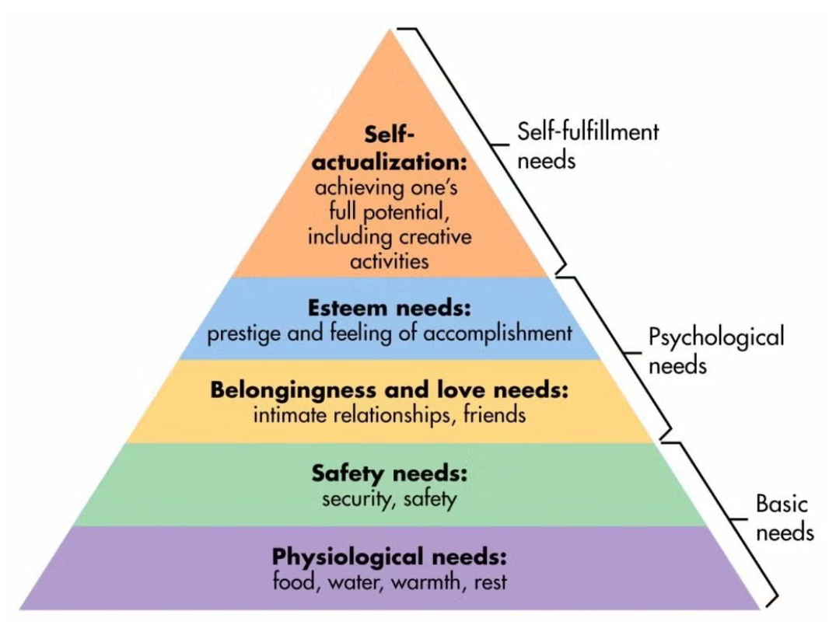

Appendix 2a
De-escalation Script – Early Years

- Child’s name

- What’s happened?

- I’m here to help you

- Tell me/Use your words/signs/symbols

- Let’s go over here and…

- Come with me and……..
Appendix 2b
De-escalation Script – KS1/2

- Learner’s name

- I can see something has happened

- I am here to help

- Talk and I will listen

- Come with me and……..

Appendix 2c
Positive language
Positive phrasing | Negative phrasing
Stand next to me  Put the book on the table  Walk in the corridor  Switch off the computer  Stay seated in your chair  please/ thank you | Stop being silly!  Be good!  Don’t throw the pen!  Stop running!  Don’t talk to me like that!  Calm down!
Limited choice/s (max. 2) | No choice (making demands)
Where shall we talk - here or in the library?  Put the pen on the table or in the box  I am making a drink - orange or lemon?  Are you going to sit on your own or with the group? Are you starting your work with the words or a picture? | Get in here now!  Get out!  Do as you are told!  Give it to me now!  Open choice: What do you want to do?/Would you like to go inside?
Disempowering the behaviour | Empowering the behaviour
You can listen from there  Come and find me when you come back  Come out from the table in your own time | Come back here, NOW!  You are not allowed in there  Get down from there!  Don't you dare swear at me!  I will let you use the computer if….
Positive scripts | Negative scripts
Take turns  Walking feet  Listening ears  Kind words  Kind hands | Do you think you’re clever?  What did you say?  Here we go again!  How many times…..
Empathising | Labelling
I am sorry that happened to you  I can see that you get angry when that happens It’s ok to feel angry about that  I’d feel angry too if that had happened | You seem angry to me  I can tell you are angry because…..

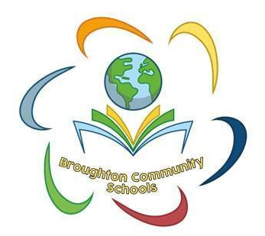
Appendix 3
Behaviour Intervention Plan
Name: | DOB: | Date: | Version of plan:  Review Date:

 |  | Areas of strengths:  Motivators: | SEN stage:  Areas of Need: | Pupil voice:
Presenting behaviours that challenge or cause harm: |  |  | Possible triggers:  Possible functions | Positive behaviours we are supporting:
 | Differentiated measures to promote / support positive behaviours

 | Positive behaviours: | What we will say and do to regulate behaviours and reinforce positives:
 | First signs of escalation: | What we will say and do to de-escalate/divert:
 | Behaviours that challenge: | What we will say and do to de-escalate/divert:
 | Behaviours that harm: | What we will say and do to best ensure safety:
 | De-escalation and Reflect / Repair / Restore

Signature of plan co-ordinator…………………………………………………………Date ………………
Signature of parent / carer….…………………………………………………………. Date ………………
Signature of young person (if appropriate) …………………………………………Date……………….
Review date:
What is working well? | What is not working well? | Next steps
Signature of plan co-ordinator………………………………………………Signature of parent / carer….………………………………………………
Signature of young person (if appropriate) ……………………………….

Review date:
What is working well? | What is not working well? | Next steps
Signature of plan co-ordinator………………………………………………Signature of parent / carer….………………………………………………
Signature of young person (if appropriate) ……………………………….

Review date:
What is working well? | What is not working well? | Next steps
Signature of plan co-ordinator………………………………………………Signature of parent / carer….………………………………………………
Signature of young person (if appropriate) ……………………………….

Ensure support and strategies outlined on this plan are regularly reviewed in line with a cycle of ‘assess, plan, do, review’.
Appendix 4
Behaviour Reflection Sheet
Name: | Date:
Adult who issued form: | Incident number (this half term):
What happened? What were you thinking at the time? What have you thought since?

_______________________________________________________________________________________
_______________________________________________________________________________________
_______________________________________________________________________________________
_______________________________________________________________________________________
_______________________________________________________________________________________
_______________________________________________________________________________________
_______________________________________________________________________________________
_______________________________________________________________________________________
How were you feeling when you made that choice? How did this make people feel?
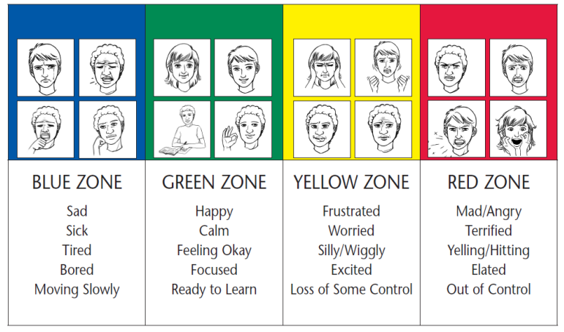

Who has been affected and how? (write or draw a picture):

What can we do to stop to prevent this happening again?

Tell an adult | Ignore | Count Backwards
Move somewhere else | Self-talk | Ask if I can move seats
Think calm thoughts | Ask the person nicely to stop | Ask for some time out
Walk away | Take 3 deep breaths | Anything else?
What can we do to put things right?
Apologise (say sorry/write a sorry letter) | Clean up | Use my words to express how I feel

How can we do things differently in the future?
Apologise (say sorry/write a sorry letter) | Clean up | Use my words to express how I feel

Is there anything I need to do to help you?
_________________________________________________________________________________________
_________________________________________________________________________________________
_________________________________________________________________________________________
Appendix 5
Class Behaviour Record  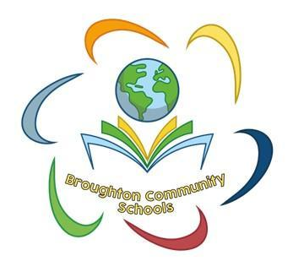 |  |  | Restorative conversation prompts
 |  |  | Tell me what happened.  What were you thinking at the time?  What have you thought since?  How were you feeling when you made that choice?  How do you think this made people feel? |  | Who has been affected and how?  What could we do to stop to prevent this happening again?  What can we do to put things right?  How can we do things differently in the future?  Is there anything I need to do to help you?
Name: |  |  |  | Class: |  |  | Year Group:
 | Date of incident | Brief details of incident |  |  |  |  |  | Initials of staff member
1.
2.
3.
Consequences  (tick when completed) |  | Comments |  |  |  | Date |  | Initials of staff member
1. Contact parents to inform.
2. Miss 5 mins at break/lunch to complete a restorative conversation using the above prompts if needed.
Date of incident |  | Brief details of incident |  |  |  |  |  | Initials of staff member
4.
5.
6.
Consequences  (tick when completed) |  | Comments |  |  |  | Date |  | Initials of staff member
1. Contact parents to inform.
2. Sent to a link teacher to reflect.
3. Invite parents in to complete a Reflection Sheet with the child and put in the behaviour file.
4. Possible natural consequence related to behaviour e.g. A relevant PSHE lesson, video clip, comic strip conversation
Date of incident |  | Brief details of incident |  |  |  |  |  | Initials of staff member
7.
8.
9.
Consequences  (tick when completed) |  | Comments |  |  |  | Date |  | Initials of staff member
1. Contact parents to inform and invite for a meeting to discuss next steps with the teacher and member of SLT.
2. Sent to SLT for internal exclusion am/pm. Complete the Reflection Sheet with the child and put in the behaviour file.
3. Educational consequence related to behaviour e.g. A relevant Jigsaw lesson, video clip, comic strip conversation, or completing work.
Date of incident |  | Details of incident |  |  |  |  |  | Initials of staff member
10.
11.
12.
Consequences |  | Comments |  |  |  | Date |  | Initials of staff member

