Broughton Community Schools

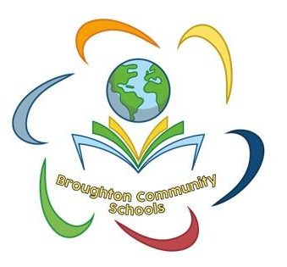

PSHE Policy
Including RSHE (Relationships, Sex and Health Education)

September 2024

Aims
To provide pupils with the knowledge, understanding, attitudes, values and skills they need in order to reach their potential as individuals and within the community.

Pupils are encouraged to take part in a wide range of activities and experiences across and beyond the curriculum, contributing fully to the life of their school and communities. In doing so they learn to recognise their own worth, work well with others and become increasingly responsible for their own learning. They reflect on their experiences and understand how they are developing personally and socially, tackling many of the spiritual, moral, social and cultural issues that are part of growing up.

They learn to understand and respect our common humanity; diversity and differences so that they can go on to form the effective, fulfilling relationships that are an essential part of life and learning.

PSHE Vision
Here at Broughton Community Schools we value PSHE as one way to support children’s development as human beings, to enable them to understand and respect who they are, to empower them with a voice and to equip them for life and learning.

Please refer to our school website for our emotional health and wellbeing statement, which details our view and vision for the wellbeing of our pupils and staff.

Objectives
In our school we choose to deliver Personal, Social, Health Education (PSHE) as a whole school approach using Jigsaw, the mindful approach to PSHE. We include the statutory Relationships, Sex and Health Education (RSHE) within our whole-school PSHE Programme.

Jigsaw PSHE will support the development of the skills, attitudes, values and behaviour, which enable pupils to:
- Have a sense of purpose
- Value self and others
- Form relationships
- Make and act on informed decisions
- Communicate effectively
- Work with others
- Respond to challenge
- Be an active partner in their own learning
- Be active citizens within the local community
- Explore issues related to living in a democratic society
- Become healthy and fulfilled individuals

Content
Jigsaw covers all areas of PSHE for the primary phase including statutory Relationships and Health Education. The table below gives the learning theme of each of the six Puzzles (units) and these are taught across the school; the learning deepens and broadens every year.

Jigsaw covers all areas of PSHE for the primary phase, as the table below shows:

Term | Puzzle name | Content
Autumn 1: | Being Me in My World | Includes understanding my place in the class, school and global community as well as devising Learning Charters.
Autumn 2: | Celebrating Difference | Includes anti-bullying (cyber and homophobic bullying included) and diversity work.
Spring 1: | Dreams and Goals | Includes goal-setting, aspirations and resilience building.
Spring 2: | Healthy Me | Includes drugs and alcohol education, self-esteem and confidence as well as healthy lifestyle choices (on and off line).
Summer 1: | Relationships | Includes understanding friendship, family and other relationships, conflict resolution and communication skills.
Summer 2: | Changing Me | Includes Sex and Relationship Education in the context of looking at and managing relationships and changes.

Jigsaw brings together PSHE Education, emotional literacy, social skills and spiritual development in a comprehensive scheme of learning. Teaching strategies are varied and are mindful of preferred learning styles and the need for differentiation. Jigsaw is designed as a whole school approach, with all year groups working on the same theme (Puzzle) at the same time. This enables a whole school focus for adults and children alike.

There are six Puzzles in Jigsaw that are designed to progress in sequence from Autumn to July. Each Puzzle has six Pieces (lessons) which work towards an ‘end product’, for example, The School Learning Charter or The Garden of Dreams and Goals.

Each Piece (lesson) has two Learning Intentions: one is based on specific PSHE learning (covering the non-statutory national framework for PSHE Education and the statutory Relationships and Health Education guidance, but enhanced to address children’s needs today); and one is based on emotional literacy and social skills development to enhance children’s emotional and mental health. The enhancements mean that Jigsaw, the mindful approach to PSHE, is relevant to children living in today’s world as it helps them understand and be equipped to cope with issues like body image, cyber and homophobic bullying, and internet safety.

Every Piece (lesson) contributes to at least one of these aspects of children’s development. This is mapped on each Piece and balanced across each year group.

The Learning Environment
Establishing a safe, open and positive learning environment based on trusting relationships between all members of the class, adults and children alike, is vital. To enable this, it is important that ‘ground rules’ are agreed and owned at the beginning of the year and are reinforced in every Piece (lesson) – by using The Jigsaw Charter. Teachers and children devise their own Jigsaw Charter at the beginning of the year so that they have ownership of it. It must include the aspects below:

The Jigsaw Charter
- We take turns to speak
- We use kind and positive words
- We listen to each other
- We have the right to pass
- We only use names when giving compliments or when being positive
- We respect each other’s privacy (confidentiality)

Delivery of PSHE
At Broughton Community Schools we allocate 1 hour to PSHE each week, within Key Stages 1 & 2, in order to teach the PSHE knowledge and skills in a developmental and age-appropriate way. In EYFS, weekly sessions are 30 minutes.

These explicit lessons are reinforced and enhanced in many ways:
Assemblies, praise and reward system, Learning Charter, through relationships child to child, adult to child and adult to adult across the school. We aim to ‘live’ what is learnt and apply it to everyday situations in the school community.

Class teachers deliver the weekly lessons to their own classes.

Differentiation/SEND
Jigsaw is written as a universal core curriculum provision for all children. Inclusivity is part of its philosophy. Teachers will need, as always, to tailor each Piece (lesson) to meet the needs of the children in their classes. To support this differentiation, many Jigsaw Pieces (lessons) suggest creative learning activities that allow children to choose the media with which they work and give them scope to work to their full potential. If any changes are implemented nationally as a result of the Rochford Review Jigsaw will make the necessary amendments and offer this free update to all its schools.

Definition of Relationships, Sex and Health Education (RSHE)
From September 2020, Relationships Education became compulsory for all primary schools as set out in the DfE Guidance (2019). For all maintained schools there is also a statutory duty to provide Health Education. This includes primary aged children learning about the ‘changing adolescent body’, included in the expected outcomes for primary Health Education. (Relationships Education, Relationships and Sex Education, and Health Education, DfE, 2019).

Effective Relationships and Sex Education can make a significant contribution to the development of the personal skills needed by pupils if they are to establish and maintain relationships. It also enables children and young people to make responsible and informed decisions about their health and well-being. This is why the DfE recommend:

“… that all primary schools should have a sex education programme tailored to the age and the physical and emotional maturity of the pupils. It should ensure that both boys and girls are prepared for the changes that adolescence brings and – drawing on knowledge of the human life cycle set out in the national curriculum for science - how a baby is conceived and born.” (Relationships Education, Relationships and Sex Education, and Health Education, DfE, 2019, para 67).

Jigsaw RSHE Content
There are four main aims for teaching RSHE within the content of primary school PSHE:
• More than ever before, children are exposed to representations of sex and sexuality through the social culture around them. The unregulated content on the internet or social media, can mean children may be exposed to dangerous, confusing or scary content. We can prepare them for this by presenting a balanced view of positive healthy relationships to help them to be discerning and to stay safe.
• There is much independent research showing most parents and carers value the support of schools in providing Relationship and Sex Education for their children. Parents and schools want children to be safe and happy.
• A range of independent research consistently shows that effective Relationship Education delays first sexual experience and reduces risk-taking in young people.
• Surveys of children and young people, as well as Ofsted, have repeatedly said that Relationship and Sex Education tends to be “too little, too late and too biological”. This is one of the many reasons why the DfE is making Relationships and Sex Education compulsory in primary schools, with an emphasis on Relationships Education.
For primary aged children, the statutory Relationships and Health Education curriculum includes content under two headings (DfE 2019):

Relationships Education | Health Education
Families and people who care for me  Caring Friendships  Respectful Relationships  Online Relationships  Being Safe | Mental Wellbeing  Internet Safety and harms  Physical Health and Fitness  Healthy Eating  Drugs, Alcohol and Tobacco  Health and Prevention  Basic First Aid  Changing Adolescent Body*
* The DfE guidance clearly states the statutory requirements. Health Education includes learning about ‘the adolescent body’ to equip children to understand and cope with puberty.
It is important to explain that whilst the Relationships Puzzle (unit) and the
Healthy Me Puzzle (unit) in Jigsaw covers most of the statutory Relationships and Health Education, some of the outcomes are also taught elsewhere in Jigsaw. This holistic approach ensures the learning is reinforced through the year and across the curriculum.

Sex Education Content
Effective Relationships and Sex Education can make a significant contribution to the development of the personal skills needed by pupils if they are to establish and maintain relationships. It also enables children and young people to make responsible and informed decisions about their health and well-being.

This is why the DfE (2019) recommends ‘…that all primary schools have a sex education programme tailored to the age and the physical and emotional maturity of the pupils. It should ensure that both boys and girls are prepared for the changes that adolescence brings and – drawing on knowledge of the human life cycle set out in the national curriculum for science - how a baby is conceived and born.”
(Relationships Education, Relationships and Sex Education, and Health Education)

In the Jigsaw programme, the ‘Changing Me’ puzzle contains the ‘explicit’ work on Puberty and Human reproduction. It is taught over a period of 6 weeks, usually in the second half of the summer term. Each year group will be taught appropriate to their age and developmental stage, building on previous years’ learning. The grids below show a brief summary of the ‘Changing Me’ puzzle in Jigsaw with respect to what is taught – when, relating to Puberty and Human Reproduction:
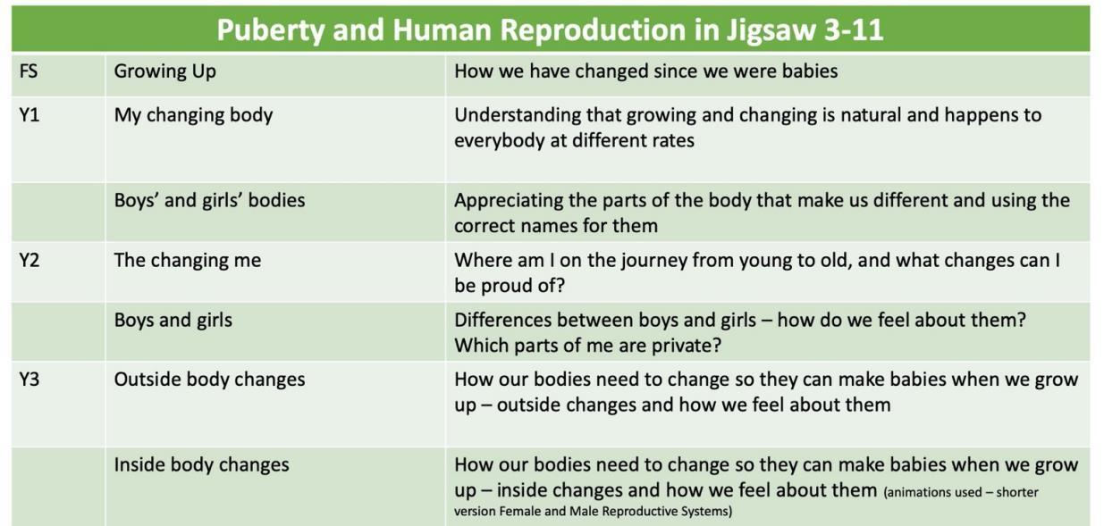

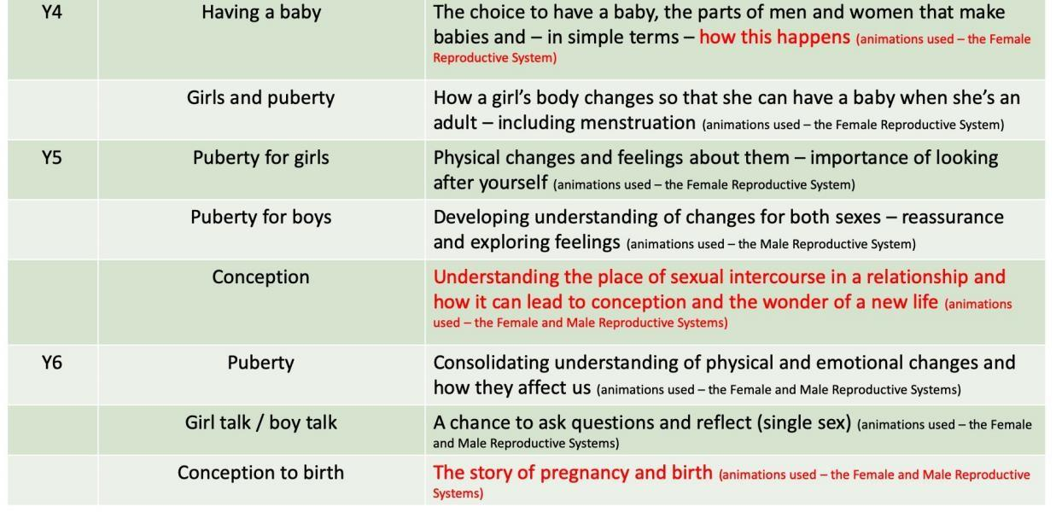

Parents’ right to request their child be excused from Sex Education
At Broughton Community Schools, puberty is taught as a statutory requirement of Health Education and covered by our Jigsaw PSHE Programme in the ‘Changing Me’ Puzzle unit, and we conclude from the DFE Guidance that sex education refers to Human Reproduction (highlighted in red in the table above).

In order to teach this in a scientific context, and knowing that National Curriculum Science requires children to know how mammals reproduce, we have opted to teach this within our Science curriculum, not within PSHE or Relationships and Sex Education as we believe this is most appropriate for our children.

Parents/carers have the right to withdraw their children from Sex Education provided at school except for those parts included in statutory National Curriculum Science and that included within Statutory Relationships and Health Education.
Those parents/carers wishing to exercise this right are invited in to see the head teacher and/or PSHE Lead in school who will explore any concerns and discuss any impact that withdrawal may have on the child. Once a child has been withdrawn they cannot take part in the specific sex education lessons until the request for withdrawal has been removed. Materials are available to parents/carers who wish to supplement the school sex education programme or who wish to deliver sex education to their children at home.

Girl’s understanding of sanitary products and disposal in school
As part of lessons on puberty in Key Stage 2, girls will be made aware of the procedures in place for accessing and the safe disposal of sanitary products. The school is aware that period poverty can be an issue for some pupils, and will to the best of its ability ensure that girls have access to appropriate sanitary products during school time.

Teaching Sensitive and Controversial Issues
Sensitive and controversial issues are certain to arise in learning from real-life experience. Teachers will be prepared to handle personal issues arising from the work, to deal sensitively with, and to follow up appropriately, disclosures made in a group or individual setting. Issues that we address that are likely to be sensitive and controversial because they have a political, social or personal impact or deal with values and beliefs include: family lifestyles and values, physical and medical issues, financial issues, bullying and bereavement.

Teachers will take all reasonable, practical steps to ensure that, where political or controversial issues are brought to pupils’ attention, they are offered a balanced presentation of opposing views. Teachers will adopt strategies that seek to avoid bias on their part and will teach pupils how to recognise bias and evaluate evidence.

Teachers will seek to establish a classroom climate in which all pupils are free from any fear of expressing reasonable points of view that contradict those held either by their class teachers or their peers.

Answering Difficult Questions and Sensitive Issues
Staff members are aware that views around RSHE-related issues are varied. However, while personal views are respected, all RSHE issues are taught without bias using Jigsaw. Topics are presented using a variety of views and beliefs so that pupils are able to form their own, informed opinions but also respect that others have the right to a different opinion.

Both formal and informal RSHE-related issues arising from pupils’ questions are answered according to the age and maturity of the pupil(s) concerned. Questions do not have to be answered directly, and can be addressed individually later. The school believes that individual teachers must use their skill and discretion in this area and refer to the Designated Safeguarding Lead if they are concerned.

Our school believes that RSHE should meet the needs of all pupils, answer appropriate questions and offer support. In Jigsaw Pieces (lessons) that cover RSHE provision, this should be regardless of their developing sexuality and be able to deal honestly and sensitively with sexual orientation and gender diversity, answer appropriate questions and offer support. LGBT+ bullying is dealt with strongly yet sensitively. The school liaises with parents/carers on this issue to reassure them of the content and context.

Involving parents and carers
The school believes that it is important to have the support of parents, carers and the wider community for the Jigsaw PSHE programme. Parents and carers are/will be given the opportunity to find out about and discuss the Jigsaw PSHE programme through:
- Parents’/carers’ evenings
- Involvement in policy development
- Involvement in curriculum development
- Information leaflets/displays

Parents/carers should be aware that schools are legally required to provide a broad and balanced curriculum. Sex and relationships topics can arise incidentally in other subjects, such as Science, Geography, History, RE, and it is not possible to withdraw pupils from these relatively limited and often unplanned discussions. Parents should be given every opportunity to understand the purpose and content of Relationships Education and RSHE. Good communication and opportunities for parents to understand and ask questions about the school’s approach can help increase confidence in the curriculum.

Equality
The DfE Guidance 2019 states, “Schools should ensure that the needs of all pupils are appropriately met, and that all pupils understand the importance of equality and respect.” Schools must ensure they comply with the relevant provisions of the Equality Act (2010) under which sexual orientation and gender reassignment are amongst the protected characteristics.

At Broughton Community Schools we promote respect for all and value every individual child. We also respect the right of our children, their families and our staff, to hold beliefs, religious or otherwise, and understand that sometimes these may be in tension with our approach to some aspects of Relationships, Health and Sex Education.

For further explanation as to how we approach LGBT relationships in the PSHE (RSHE) Programme please see the following guidance available in the website: ‘Including and valuing all children. What does Jigsaw teach about LGBTQ relationships?’

Confidentiality and Safeguarding
As a general rule a child’s confidentiality is maintained by the teacher or member of staff concerned. If this person believes that the child is at risk or in danger, she/he talks to the named safeguarding lead, who acts as laid down in the Safeguarding Policy. All staff members are familiar with the policy and know the identity of the member of staff with responsibility for Safeguarding issues. The child concerned will be informed that confidentiality is being breached and reasons why. The child will be supported by the teacher throughout the process.

External contributors
External contributors from the community, such as health promotion specialists, school nurses, social workers, and community police and fire officers, make a valuable contribution to the Jigsaw PSHE programme. Their input is carefully planned and monitored so as to fit into and complement the programme. Teachers MUST always be present during these sessions and remain responsible for the delivery of the Jigsaw PSHE programme.

Assessment
Teachers will be eager to ensure children are making progress with their learning throughout their Jigsaw experience. Therefore, each Puzzle (unit of work) has a built-in assessment task, usually in Lesson (Piece) 6. This task is the formal opportunity for teacher assessment, but also offers children the chance to assess their own learning and have a conversation with the teacher about their two opinions. In addition, as part of the ‘Help me Reflect’ section of every Jigsaw lesson, children can complete a self/peer assessment using the My Jigsaw Journey/Learning resource that accompanies each lesson. All assessed work can be collated as part of the children’s Jigsaw Journals.

Recording and tracking progress
To support the teacher in tracking each child’s Jigsaw Learning progress throughout the year, there is a Pupil Tracking Grid. This sheet has the three attainment descriptors for each Puzzle. After each Puzzle is completed, the teacher, using a best-fit approach, decides whether the child is working at, towards or beyond and highlights the appropriate descriptor box on that child’s overview sheet. There is also space for the teacher’s comments. This sheet gives a quick visual representation of where the child is in each Puzzle.

Monitoring and evaluation
The PSHE subject lead will monitor delivery of the programme through observation and discussion with teaching staff to ensure consistent and coherent curriculum provision.
Evaluation of the programme’s effectiveness will be conducted on the basis of:
- Pupil and teacher evaluation of the content and learning processes
- Staff meetings to review and share experience.

Training and support for staff
All staff benefit from Jigsaw PSHE training in order to enhance their PSHE delivery skills. Opportunities are provided for staff to identify individual training needs on a yearly basis and relevant support is provided.
The role of the Headteacher and Governing body
It is the responsibility of the Governors to ensure that as well as fulfilling their legal obligations, the governing boards or management committee should also make sure that:
• all pupils make progress in achieving the expected educational outcomes in regard to PSHE & RSHE;
• PSHE & RSHE is well led, effectively managed and well planned;
• the quality of PSHE & RSHE provision is subject to regular and effective self-evaluation;
• teaching is delivered in ways that are accessible to all pupils with SEND;
• clear information is provided for parents on the subject content and the right to request that their child is withdrawn; and,
• the subjects are resourced, staffed and timetabled in a way that ensures that the school can fulfil its legal obligations.

The headteacher liaises with external agencies regarding the school PSHE & RSHE programme and ensures that all adults who work with children on these issues are aware of the school policy, and that they work within this framework. The headteacher monitors this policy on a regular basis and reports to governors, when requested, on the effectiveness of the policy.

Dissemination
This policy is available on our school website where it can be accessed by the community. Training is regularly delivered to staff on the policy content. Copies are available from the school office on request from parents/carers.

Links to other policies and curriculum areas
We recognise the clear link between Jigsaw PSHE and the following policies and staff are aware of the need to refer to these policies when appropriate, which can be found our school website:
- Safeguarding/Child Protection Policy
- Special Educational Needs Policy
- Teaching and Learning Policy
- Anti-Bullying Policy
- Behaviour Policy
- SMSC Policy
- Confidentiality Policy
- Drug and Alcohol Education Policy
- Equal Opportunities Policy
- Health and Safety Policy
- ICT Policy and Safe Internet Use Policy
- Science curriculum
- Inclusion Policy
- RE Policy

Reviewed by: Carla Kitchen
Date: September 2024
Review date: September 2025

