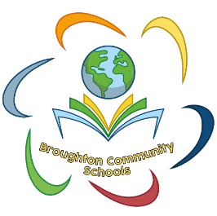
Key skills to improve mental fluency:
- Number bonds within 10
- Number bonds to 10
- Number bonds within 20
- Number bonds to 20
- Doubles up to 20
- Halves within 20
- Near doubles
- Times tables
- Square numbers

All these skills can be applied to larger numbers.
Maths
Home Learning
Our Expectations
At Broughton Community Schools, our Home-Learning for Maths is;
- Practise their 99 club to consolidate their learning in class.
- Power Maths – Whole school
- TTRockstars – Key Stage 2 (Year 2 Summer term)
For more information about Maths please speak to the class teacher or visit the Maths section of our website:
https://www.broughtoncommunityschools.com/maths/

Maths in the Environment
Maths is everywhere and sharing this with your children whilst out and about will also help with their Maths.
- Looking at house numbers
- Counting cars
- Playing board games
- Number hunt in a supermarket
- Writing numbers in sand, chalk etc
- Counting steps

TTRockstars 
Children can practise their times tables at home by logging in to the TTRockstars website on iPads and tablets as well as desktop and laptop computers. Times Tables Rock Stars is a maths programme that takes all the worry out of learning times tables and has a proven track record of boosting children's fluency.
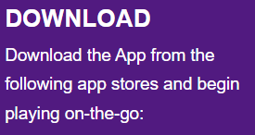


Your child has their own Power Maths account that they can access at home. They will be able to practice what they have learned in class, and you will be able to enjoy the experience with them. There are also pupil videos the children can watch at home linked to the learning in class.
The children should have brought a letter home about access.
Their personal username and password can be found inside the front or back cover of their Reading Diary.

Broughton Community Calculation Policy
This can be found in the Maths section on the school website.
It is a very useful document going through the main calculations showing the progress from EYFS to Year 6.

